# Pressure effect on Al-Si alloys

## Pressure crystallisation

The pressure crystallisation process is similar to HPDC, with the difference that the piston shares a larger area with the casting. This process has been studied extensively in Russia. A schematic of pressure crystallisation (after [1]) is shown in figure 1.



Figure 1. Pressure crystallisation process.

According to K.A. Batyshev, At a pressure above 50-80 MPa the temperature of crystallisation of the metal increases by 5-12 °C. [1]

Increasing pressure increases content of second component in solid solution for Al-Si, Al-Fe, Al-Mn, Al-Sn, Al-Pb, Al-Cr, Al-Cd and Al-Pb. In only Al-Zn and Al-Mg did solubility of second component decrease with pressure. [2]

Casting in 100 MPa causes grain refinement of order 2-3 compared to atmospheric casting. Most likely, this is caused by increase in cooling rate, not pressure itself. Also, a shift of eutectic towards silicon due to high pressure reduces size of primary silicon. Silicon is detrimental to physical properties, fail by chipping before specimen. [3]

According to K. A. Batysev, solidification time for binary alloys in high pressure casting follows the equation:

|  |  |
| --- | --- |
| $$τ_{s}=τ_{r}-K \sqrt{P_{r}}$$ | (1) |

Where $τ_{s}$ is the actual solidification time, $τ_{r}$ is the solification time at atmosphere pressure, $K$ is a constant and $P_{r}$ is the rated pressure. This is demonstrated for Al-Si in figure 2. The dependencies are stated to be also valid for Al-Cu and Al-Mg. This relationship was measured for a cylindrical pressure crystallisation casting with a piston. [1]

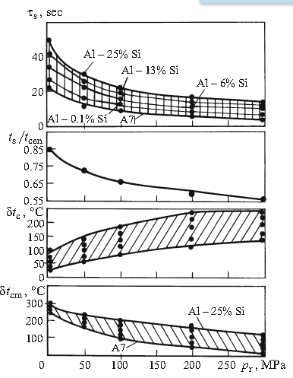

Figure 2. Dependence of solidification of a casting ($τ_{s}$) of the relative surface temperature ( $t_{s}/t_{cen})$ and of the temperature drop over cross section ( $δt_{c})$ and on the “casting/mold” interface ($δt_{cm}$) on the rated pressure $(p_{r}$) for Al-Si alloys. [1]

According to Lipchin (1986), For Al-Si in pressure crystallisation, solid solution is close to 0 at 0 Mpa, 0.2% at 100 MPa, 0.4 % at 200 Mpa and 0.9% at 400Mpa. Solubility seems unaffected by %Si. [2] These results are shown in figure 3.

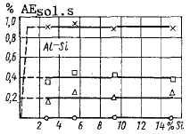

Figure 3. Al-Si solubility as function of pressure [2]

Nikulin (1997) studied the effect of pressure on the Al-Si phase diagram [4]. According to his analysis, at 100 MPa, the change in the phase diagram is insignificant. However, the growth in melting temperature by about 6K could be significant. The change in critical values as a function of temperature based on their analysis is shown in figure 4.

According to Nikulin, the grain refinement in high pressure casting is caused by the stimulation of nucleation by a high-pressure pulse. These rapidly nucleated fine dendrites have a Si content of 1.40%, over twice that of coarse dendrites at 0.86%. [4] These experiments were carried out by applying a 100MPa pressure during crystallisation temperature.

The effect of pressure on Al-Si system was also studied by A. Zyska et al. Their experimental setup had 60MPa pressure applied for 50 seconds during solidification. They found that squeeze casting shortens the solidification period of casting by 1.5 to up to 5 times. This is caused by the pressure mostly eliminating the shrinkage gap between the mold and the material. The shortened solidification time is associated by a refinement of the eutectic and promotion of the alpha-phase at the expense of silicon. They proposed that this causes significant segregation of silicon, which can lead to the formation of the primary silicon phase even in hypoeutectic alloys. [5]

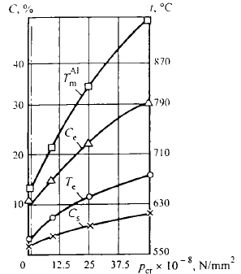

Figure 4. Effect of pressure in crystallisation on the position of critical points of the Al-Si diagram. The vertical dash line corresponds to a pressure of 100 N/mm^2) [4]

## Pressure casting for other binary Al-alloys

Lipchin also determined solubilities for other binary Al- alloys in pressure crystallisation. For Al-Cu, solubility is dependent on %Cu as well as pressure. For alloy A383 mod., Cu% is 2.53. This would give solubility 0.9% at 0Mpa, 1.3% at 100Mpa, 1.8% at 200Mpa and 2.3% at 400Mpa. These results are shown in figure 5. [2]

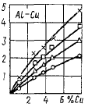

Figure 5. Al-Cu solubility as function of pressure and alloying [2]

For Al-Mg, Lipchin found that increasing pressure decreases solubility. Experimental data for such low alloying is not available on this publication, but it appears that effect of decreasing pressure is additive, and that the effect of increased alloying is linear. [2] This is shown in figure 6.

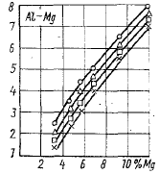

Figure 6. Al-Mg solubility as function of pressure and alloying [2]

Lipchin found that some of the solubility increase was due to increased solute trapping due to the effect of pressure on cooling rate in pressure crystallisation. The results are shown in figure 7. For Al-Cu and Al-Mn, increase in alloying is explained solely by increase in cooling rate, not pressure itself.

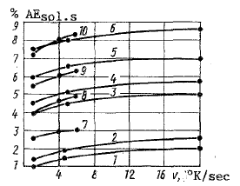

Figure 7. Cooling rate effect on solubility. 1) Al-2.8% Cu: 2) Al-3.9% Cu, 3) Al-5.8% Mg; 4) Al-6.8% Mg; 5) Al-9.2% Mg; 6) Al-12.2% Mg; 7) Mg-3.4% Al; 8) Mg-5.2% Al; 9) Mg-7.3% Al; 10) Mg-12.2 % Al. After [2]

Lipchin also determined the effect of pressure on phase diagram for various binary alloys. The results are shown in figure 8. For 100 MPa pressure, the effect is in range of 2-5 K for Al-Mg, Al-Cu and Al-Zn. [2]

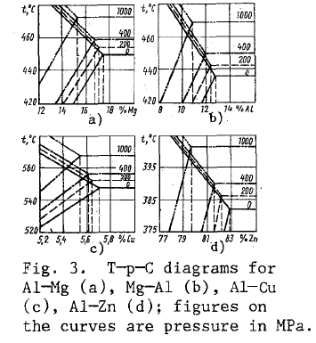

Figure 8. Effect on phase diagram of pressure. A) Al-Mg, b) Mg-AL, c) Al-Cu, d) Al-Zn [2]

## Mechanical properties and heat treatment of pressure casting

L. Stancek et al. studied the effect of heat treatments on microstructure and mechanical properties in the crystallization under pressure PCC process. In this process, an AlSi7Mg0.3 alloy was subjected to 100 MPa pressure over 30 seconds in an 80° C, causing cooling rates of 600-800 K/s and fine microstructure. After removing, the parts were subjected to T6 heat treatment. (quenching and natural aging.

The final mechanical properties were 370 MPa rupture strength (+50-60 MPa from heat treatment) and 12% average elongation. Elongation was strongly affected by spheroidization and refinement of the silicon phase. [6]

## Effect of pressure on silicon growth mechanism

Li Lixin et al. studied the solidification microstructure of Al-Si at pressure of 4.0 and 5.0 GPa. They reported a refinement of the eutectic structure as well as a gradual shift of the eutectic composition towards silicon. No new phases were detected. [7]

Li Lixin et al. also showed thermodynamically that high pressure favours the growth of Al at the expense of Si. This was derived from thermodynamic principles:

|  |  |
| --- | --- |
| $${\left[\frac{∂\left(ΔG_{v}\right)}{∂P}\right]}_{T}=V^{L}-V^{S}$$ | (2) |

Therefore if the volume of the solid phase is less than the liquid phase, $ΔG$ will increase with pressure, and vice versa. For Al and Cu, the solid phase has less molar volume than liquid. The opposite is true for Si and Ge. Based on this and geometrical considerations, they argue that eutectic silicon will change its growth mechanism to a non-faceted form at high pressures, and that silicon growth is inhibited by pressure. [8]

## Effect of pressure on heat transfer coefficient

Batysev et al. studied the effect of pressure on the heat transfer coefficient in the pressure crystallisation process. They found that in high pressure (200MPa), the heat transfer coefficient stays constant until the end of casting. In atmospheric conditions, heat transfer coefficient drops over time. These results are shown in figure 9. [1]

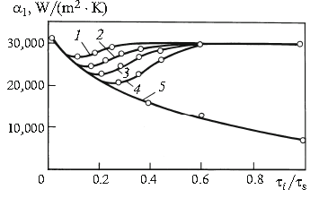

Figure 9. Variation of the coefficient of heat transfer $α_{1}$ during solidification of castings ( $τ_{i}/τ_{s}$ is the relative time of solidification): 1,2,3,4 alloys Ak18N, AK12, AK7ch and aluminum A7, respectively (the rated pressure in solidification $p_{r}=200MPa$). 5) All the other alloys (solidification at atmospheric pressure. Dip in $α$ takes place before pressure is applied. [9]

## Pressure drop during solidification

Batysev also studied the effect of friction on the pressure drop during solidification in the pressure crystallisation process.. Using the Mises condition, the pressure drop during compaction of solidifying cylinder with diameter D and height H can be calculated using equation [1]:

|  |  |
| --- | --- |
| $$\frac{Δp}{p}=\frac{2}{\sqrt{3}}\frac{σ_{s}}{p} \left(1+\frac{2H}{D}\right)$$ | (2) |

Where $σ_{s}$ is the yield strength of the alloy in the deformation temperature. The writers assume that the casting will be dense when $\frac{δp}{p}<0.4$. This requires a $\frac{H}{D}<1$ when $p≥100 MPa$. Generally, this means that a high $\frac{H}{D}$ ratio leads to a larger relative loss of pressure due to external friction. Their results for pressures 10, 50 and 200 MPa are shown in figure 10. [1]

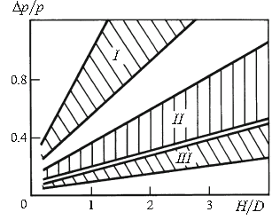

Figure 10. Relative loss of pressure to external friction $\left(\frac{Δp}{p}\right)$ as a function of the ratio of height H to diameter D of the casting. Areas 1,2,3 have rated pressure of 50, 100, 200 MPa ( the lower boundary of each domain at $σ_{s}-5MPa$, the upper boundary at $σ_{s}-10MPa$.

Hu et al. studied the effect of the onset of solidification on pressure drop in high-pressure die casting. [10] According to their work, pores may be formed during the final steps of solidification due to the pressure drop. [10] They calculated the local solidifying pressure with Ansys, estimating that the pressure drop is caused by the strength of solidifying alloy. The effect of friction was not accounted for, which may cause the overestimation. The results are shown in figure 11.

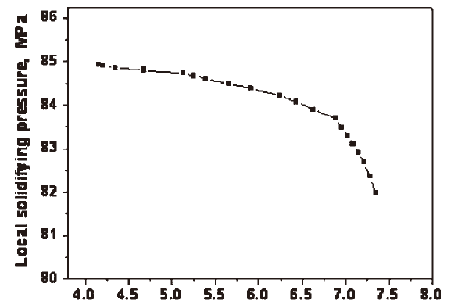

Figure 11. Pressure drop during solidification in HPDC of AlSi10Cu3 alloy [10]

## Experimental results for solubility and eutectic temperature for the Al-Si system

According to Ikuya Fujishiro et al. the eutectic of the Al-Si system is raised from 577°C to 660 °C from 0 MPa to 2.8 GPa. This gives a pressure derivative of 3°C/100MPa. Similarly the solid solubility of silicon was determined to be 7.0 at% at 2.8 Gpa vs 1.6 at% at 0GPa. This gives a rate of change of 0.2at%/100Mpa. [9] Mii et al. extended these measurements to 5 GPa. [11]

Kingon et al. also studied the effect of pressure on the eutectic of the Al-Si system. Their results are shown in figure 12. [12]

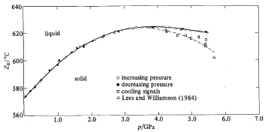

Figure 12. Effect of pressure on Al-Si eutectic temperature [12]

## Industrial alloys

J.P. Petitet et al. (1991) studied the effect of pressure on the AS12UN alloy (composition 0.6% Fe, 11-13 % Si, 0.8-1.50 % Cu, 0.20 % Mn, 0.40-0.80 % Mg, 0.20 % Zn, 0.20% Ni, 0.10% Ti, 0.10 Pb, 0.05 % Sn) using DTA in a HPDC process. [13] They established a linear equation for the eutectic and liquidus temperature based on pressure:

Eutectic : $T=569+3.5⋅{10}^{-4} P (MPa)$

Liquidus (P<50MPa): $T=575-5.7⋅{10}^{-4} P (MPa)$

Liquidus (P>50Mpa): $T=568+6.8⋅{10}^{-4} P (MPa)$

These results are visualised in figures 6 and 7. Similarly, the solid solubility of alpha and the concentration of the eutectic where modelled with linear equations of pressure:

Eutectic C(w%): $12+3.7⋅{10}^{-5} P (MPa)$

Solid solubility $α$ (w%): $1.9+7.45⋅{10}^{-5} P (MPa)$

The experimental results and the linear fits are shown in figures 13 and 14.

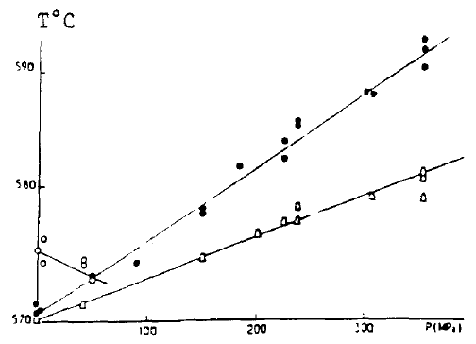

Figure 13. Change of temperature of liquidus (circle) and eutectic (triangle) vs pressure [13]

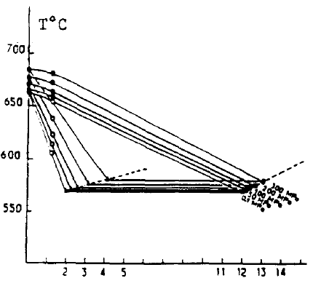

Figure 14. Change of phase diagram vs Pressure (0-300MPa) [13]

## Simulation

J. J. Sobczak et al. calculated the pressure effect on the Al-Si phase diagram using thermocalc and the Birch-Murnagham equations of state. Their calculation showed very minor shift in the phase diagram and silicon solubility over 100MPa pressure as shown in figures 16 and 16.

The use of the Birch-Murnagham EOS was challenged by Eli Brosh et al., who analysed the application of the CALPHAD process to high-pressure equilibria for Al, Si, MgO, Fe and Al-Si. They found that the present equations of state, the Birch-Murnagham EOS and the Jacobs-Oonk EOS lead to unphysical conclusions in high pressure, and formulated a new EOS. They achieved a moderate match with Kingon’s [12] and Mii’s [11] experimental results. [14] Their results are shown in figure 17 and 18.

An equation of state for the Al-Si and Al-Ge systems was also formulated by Soma et al. using electronic theory based on pseudopotentials and the virtual crystal approximation for the disordered alloy. [15]

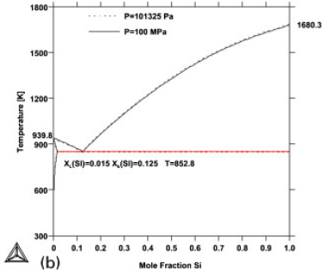

Figure 15. Effect 100MPa pressure on the Al-Si phase diagram (dotted line) [16]



Figure 16. Effect of pressure on eutectic concentration [16]

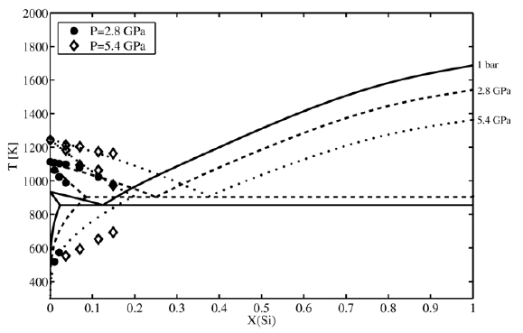

Figure 17. Calphad calculation of phase diagram vs. experimental data from Fujishiro (circle) [9] and Mii (diamond) [11] from [14].

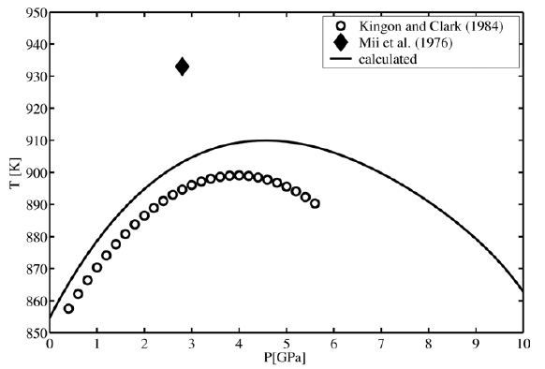

Figure 18. Eutectic temperature of Al-Si alloy as a function of pressure vs. experiments by Kingon and Clark [12] and [11] (after [14])

## Conclusions

1. Effect of 100Mpa pressure on equilibrium solubility of silicon is approx. 0.2 %.
2. Effect of 100Mpa pressure on eutectic temperature is 2-10 K.
3. Adequately accurate simulations of high-pressure phase diagram for binary systems are possible, and experimental agreement is quite good for at least up to 5GPa.
4. Friction and increase of biscuit strength cause pressure to drop during late stages of solidification. This may be a factor for porosity.
5. Sustained over 50MPa pressure significantly increases heat transfer due to elimination of shrinkage gap, leading to refinement of eutectic, shorter solidification time.
6. Increased pressure increases solidification temperature of Al and decreases solidification temperature of Si. (due to thermodynamics), which promotes growth of alpha. This in turn can cause significant silicon segregation and primary silicon crystals.

[1] K.A. Batyshev. Casting of Aluminum Alloys with Pressure Crystallization. Part 1, Met Sci Heat Treat+ 53 (2012) 463-471.

[2] T.N. Lipchin. Alloying Capacity for the Solid-Solution of Alloys Obtained by Crystallizing under Pressure, Met Sci Heat Treat+ 28 (1986) 282-285.

[3] K.A. Batyshev. Casting of aluminum alloys with pressure crystallization. Part 2, Met Sci Heat Treat+ 54 (2012) 55-62.

[4] L.V. Nikulin. Crystallization conditions and structure of Al-Si alloys in casting under pressure, Met Sci Heat Treat+ 39 (1997) 384-389.

[5] Z.K. A. Zyska P , M. Łągiewka, M. Nadolski, . The influence of modification and squeeze casting on properties of AlSi11 alloy castings ARCHIVES

Of

FOUNDRY ENGINEERING Volume 11 (2011) 153–156.

[6] L. Stancek, B. Vanko, A.I. Batyshev. Structure and Properties of Silumin Castings Solidified Under Pressure After Heat Treatment, Met Sci Heat Treat+ 56 (2014) 197-202.

[7] M.L. L. X. Li, L. W. Zhang. Effects of High Pressure on the Solidification Microstructure of Al-Si Alloy, Advanced Materials Research 320 (2011) 14-19.

[8] M.L. L. X. Li, H. X. Wang. Eutectic Growth Mode of Al-Si Alloy Solidified Under High Pressure, Applied Mechanics and Materials 130-134 (2011) 1020-1025.

[9] H.M. Ikuya FUJISHIRO1, Masafumi SENOO1, Masaru AKAO1. High Pressure Phase Diagram of Al-Si System, Journal of the Society of Materials Science, Japan 20 (1971) 952-955.

[10] X.P. Hu, G.Q. Zhao, W.M. Wang. Solidifying pressure and microstructure of AlSi10Cu3 in die sleeve in high pressure die casting, Int J Cast Metal Res 23 (2010) 289-295.

[11] H. Mii, M. Senoo, I. Fujishiro. Solid Solubility of Si in Al under High-Pressure, Jpn J Appl Phys 15 (1976) 777-783.

[12] J.B.C. A. I. Kingon. The aluminium-silicon system to 5.5 GPa, High temperatures. High pressures 16 (1984) 137-141.

[13] L.M.Z. J. P. Petitet , M. H. Ambroise & T. Verdet. Effect of the pressure on Al-Si alloys, High Pressure Research 7 (1991) 222-224.

[14] E. Brosh, G. Makov, R.Z. Shneck. Application of CALPHAD to high pressures, Calphad 31 (2007) 173-185.

[15] T. Soma, Y. Funayama, H.M. Kagaya. Formation of Al-Si and Al-Ge Solid-Solutions and Equation of State, Solid State Commun 77 (1991) 149-153.

[16] J.J. Sobczak, L. Drenchev, R. Asthana. Effect of pressure on solidification of metallic materials, Int J Cast Metal Res 25 (2012) 1-14.